Instructions

Entering a game:

1. Once you have logged in, enter the name for your character in the first input box.
2. The first slider allows you to choose your class (first position is Cambion, second position is Nephilim, third position is Phoenix).
3. The second slider allows you to choose if you want to create a new game, or to join an already existing one. If you are to join a game, you’ll need the ID from someone else’s game (which they can find either as they make the game or in the link of their game instance). If you’re creating a new game, it’s just a matter of clicking the buttons to continue on!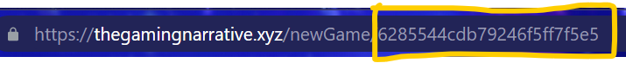

Once in the Game:

1. 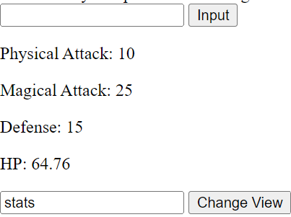For each room, you have a limited number of acceptable commands. However, you can always do the same three different views by typing inventory, moves, or stats (although you do start with an empty inventory).

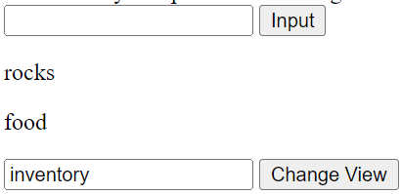

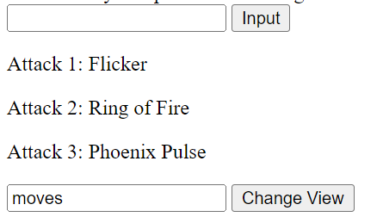

1. Although it may take some trial and error, the general format of the Input commands are as follows:
   1. move ____ where the blank is replaced with north, south, east, or west. If there aren’t indications of where to go in the dialogue, then you’re likely meant to do at least one of the following commands first.
   2. pickup ____ where the blank is replaced with an item you want to pick up. You won’t have to move towards an item before doing this interaction, it’s just a matter of taking what may be in the surrounding environment.
   3. attack ____ with ____ where the first blank is replaced with the type of monster you are presently facing (for example, vampire or wolf), and the second blanks is replaced with what you’re using to attack. This may be an item you’ve picked up, or the number of one of your attacks you’d like to use (1, 2, or 3).
   4. use ____ on ____ which can be used similarly to the attacking command. The first blank is replaced with the item you’re utilizing, whereas the second blank is replaced with the type of monster you are presently facing.
   5. eat ____ where the blank is replaced with food or groceries, depending on which you picked up. This may be helpful in restoring a bit of HP.
2. Using the above commands, it is up to you (and potentially the rest of your party!) to reach the finishing line—“At least, in what's left in your hometown.” Any steps you take to get there are part of your epic journey to start saving the world, starting with the very place you’ve found yourself to be.